Lesson 4 Demo 1: Create a Bridge Network

This section will guide you to:

* Create a default network in Docker
* Inspect the network for the network driver

**Step 1:** Create a network that will take the *bridge driver* by default

* Use the following command to create a network:

*sudo docker network create mynetwork1*

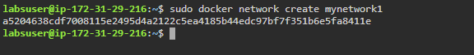

* Use the following command to list current networks:

*sudo docker network ls*

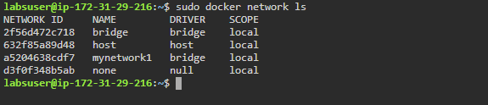

* Use the following command to inspect the network:

*sudo docker network inspect mynetwork1*

**Note:** A *bridge* driver is the default driver that automatically gets installed and configured while creating a network.

